**4: Kubernetes Liveness & Readiness Probes Introduction**

--- in this lecture, we will understand probes available in the kubernetes cluster. We have total 3 types of probes available.

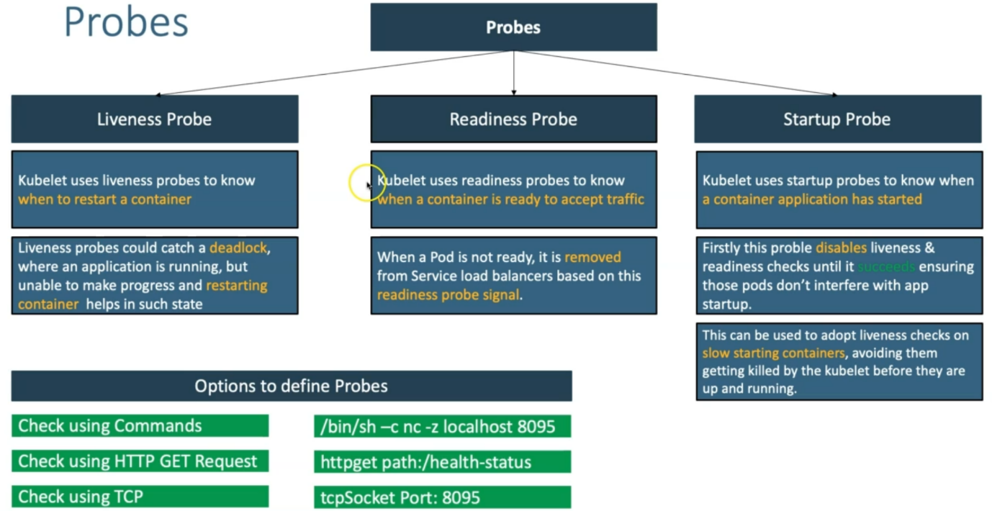

--- **/bin/sh -c nc -z localhost 8095** – to check the application is running on port 8095 or not.

--- **httpget path://health-status** – providing health status of application probes to determine the application running or not.